Lab 18: Wireless Networking Attack and Mitigation Techniques

Contents:

1 Examining Plain Text Traffic

1.1 Viewing Plain Text Wireless Traffic

1.1.1 Extract Image from Capture

1.1.2 Extract Zip File from FTP Traffic

2 Exploiting and Examining WEP Traffic

2.1 Decrypt and Analyze WEP Traffic

3 Exploiting and Examining WPA Traffic

3.1 Exploiting and Examining WPA Traffic

1 Examining Plain Text Traffic

* 1. Viewing Plain Text Wireless Traffic

Step 1. Access the Kali VM

Step 2. Log in with credentials provided username: kali password: kali

Step 3. Find and double click on the folder named captures

Step 4. Launch the httpcapture.cap file to open it in Wireshark

Step 5. Maximize the windows on Wireshark

Step 6. Select the first frame in the Wireshark capture file

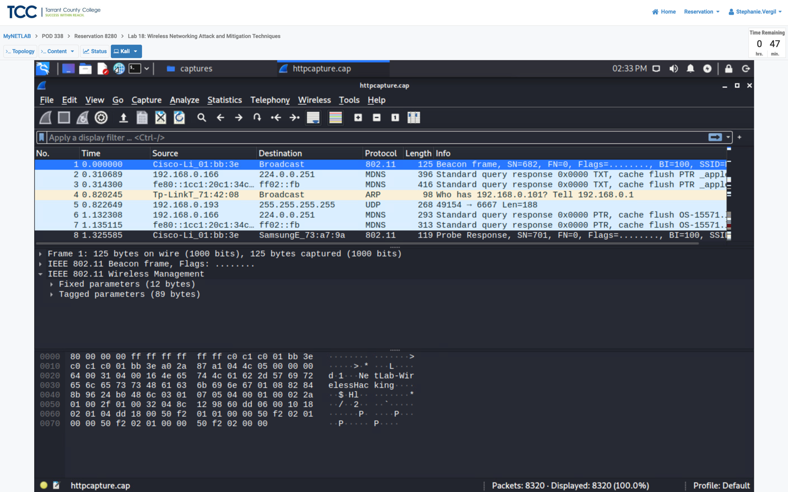



Step 7. On the middle of the screen, click on the arrow to expand in front of the IEEE 802.11 Wireless Management.

Step 8. Continue to expand the Tagged Parameters (89 bytes), expand the Vender Specific: Microsoft Corp.: to view the WPA Version

(you can drag the handle to make the packet detail section larger)

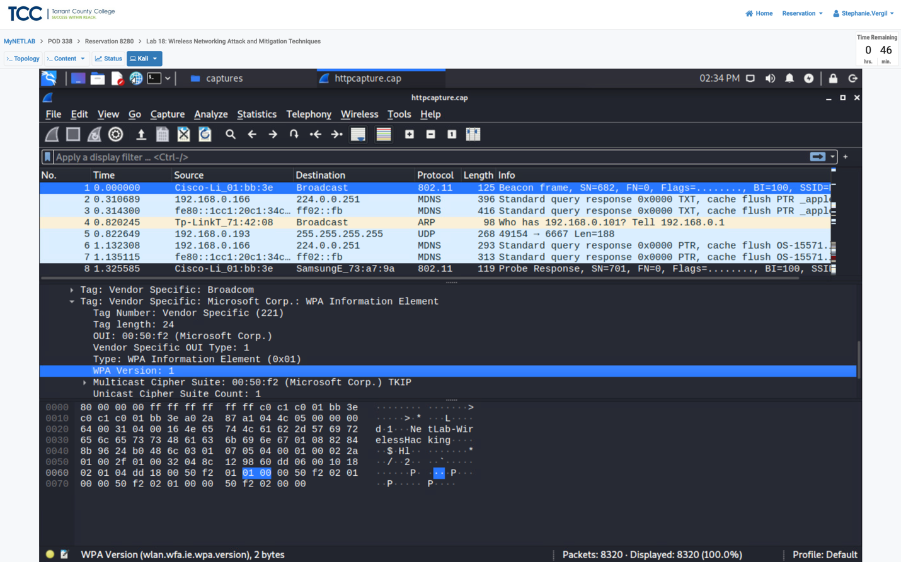



Step 9. To view the captured DNS requests by typing “dns” in the filter pane, and press enter.

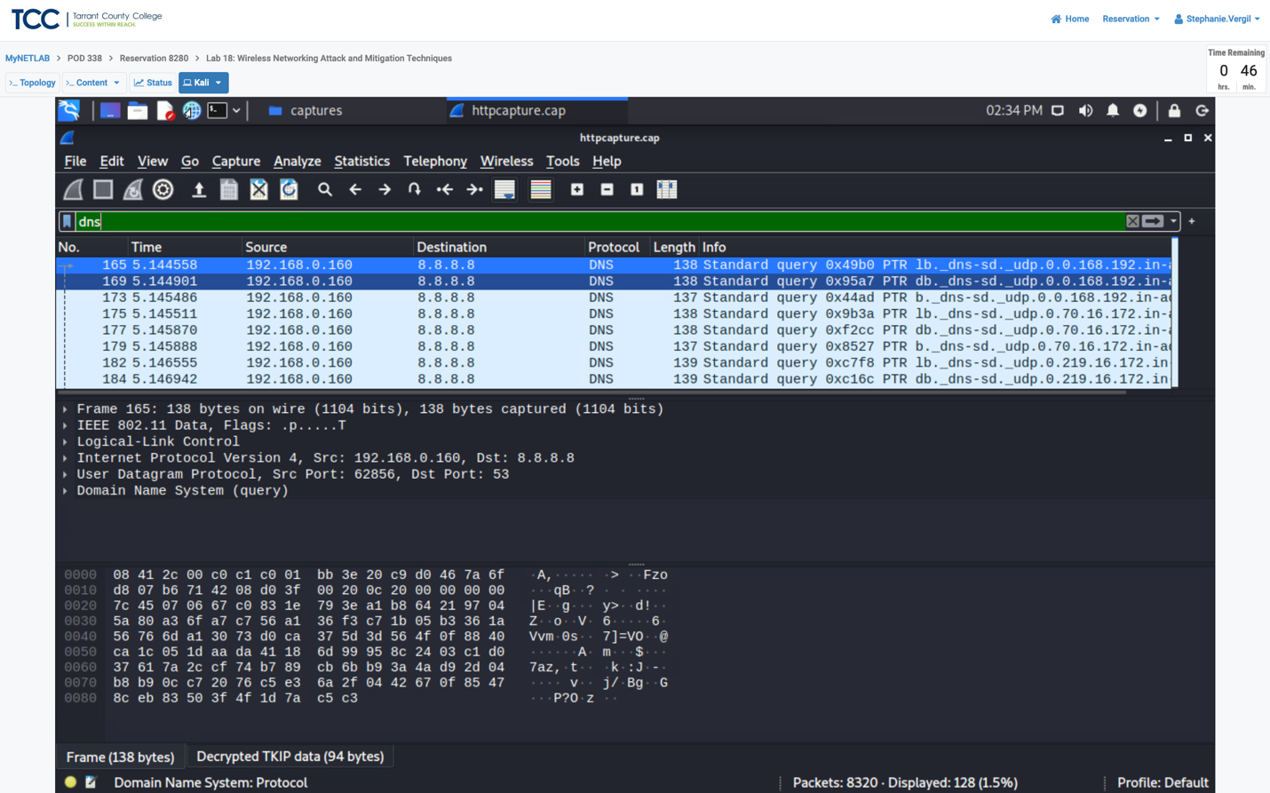



1.1.1 Extract Image from Capture

Part 1. In Wireshark click on file on the menu option on the top pane navigating to Export Objects and click on HTTP

Part 2. On the new window that appears, you can view the list of files that have been downloaded by wireless user. Look for the image file Securityv4.jpg under the filename column, you can click the preview button to view.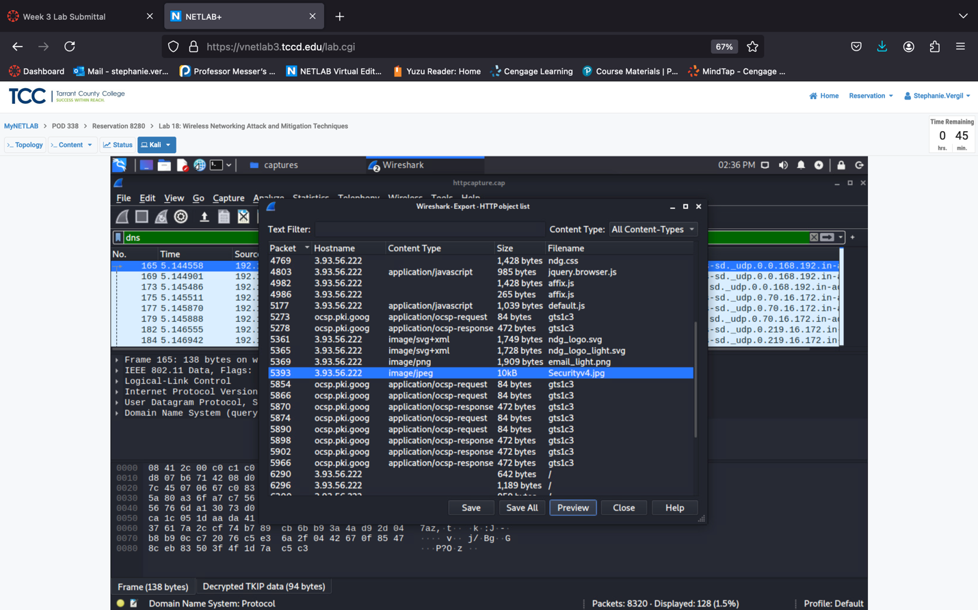



Step 3. Preview window will open, and it shows a topology. Close preview when done viewing.

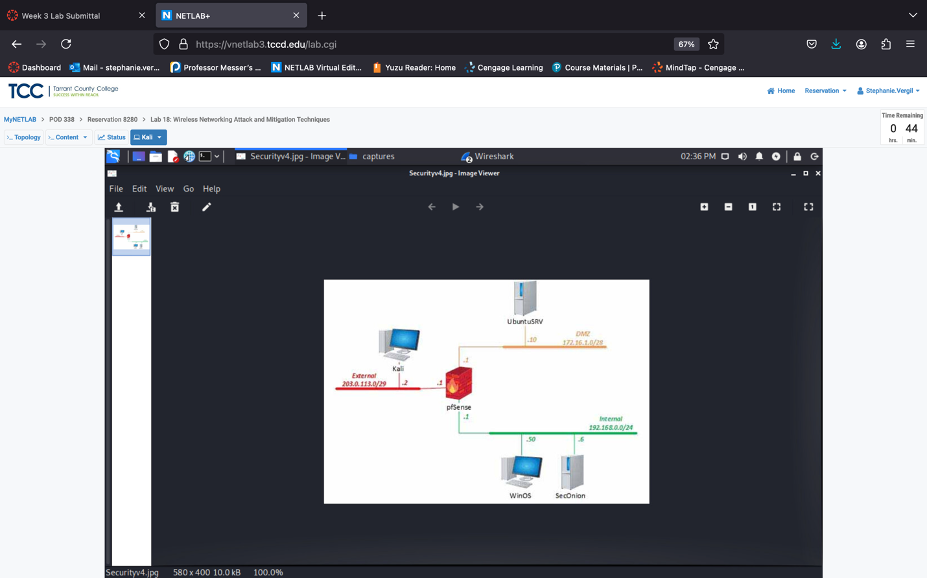

Step 4. Save the Securityv4.jgp file.

Step 5. Choose the /home/kali/Desktop directory to save file.

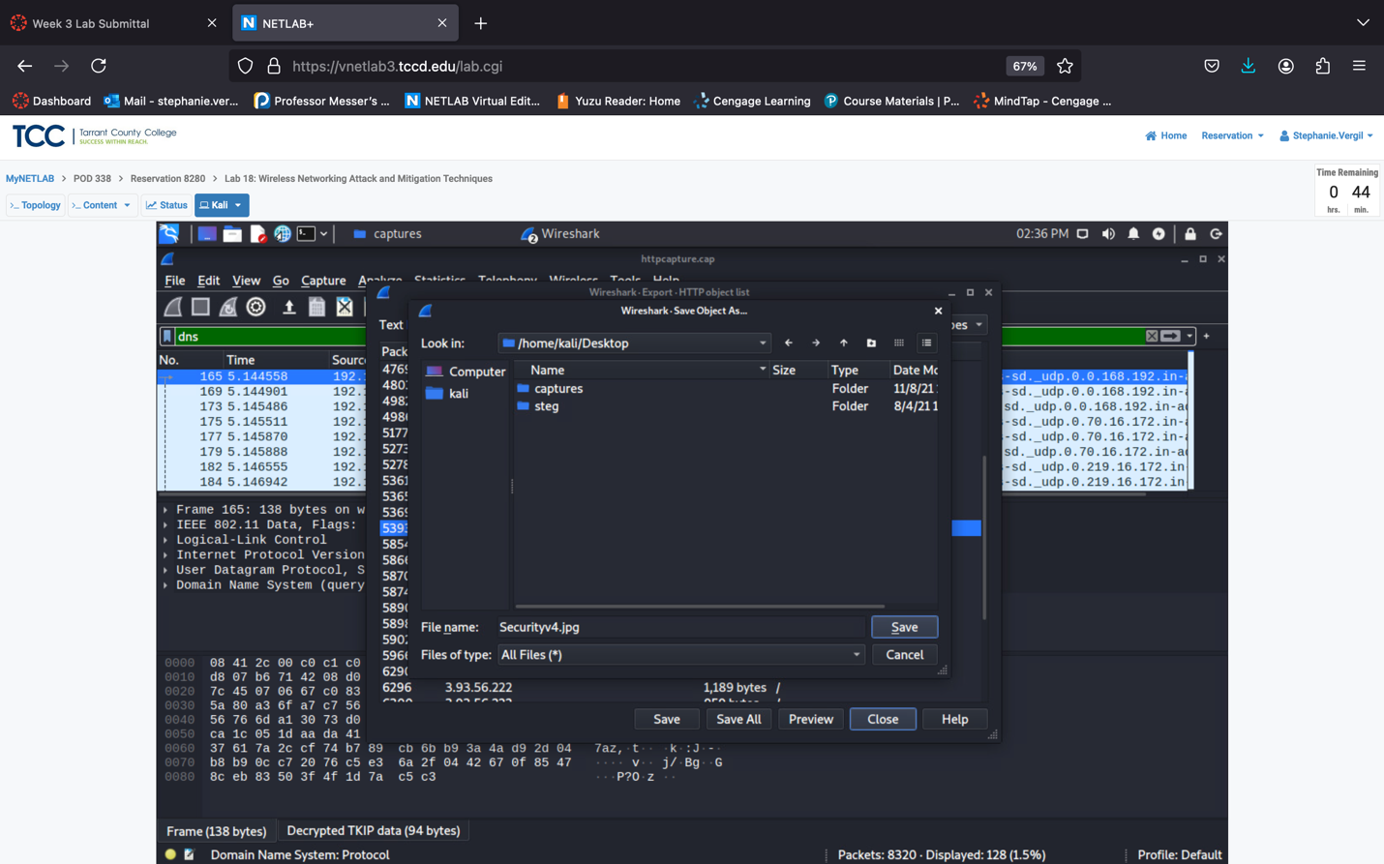



Step 6. Launch the image, located at desktop.Step 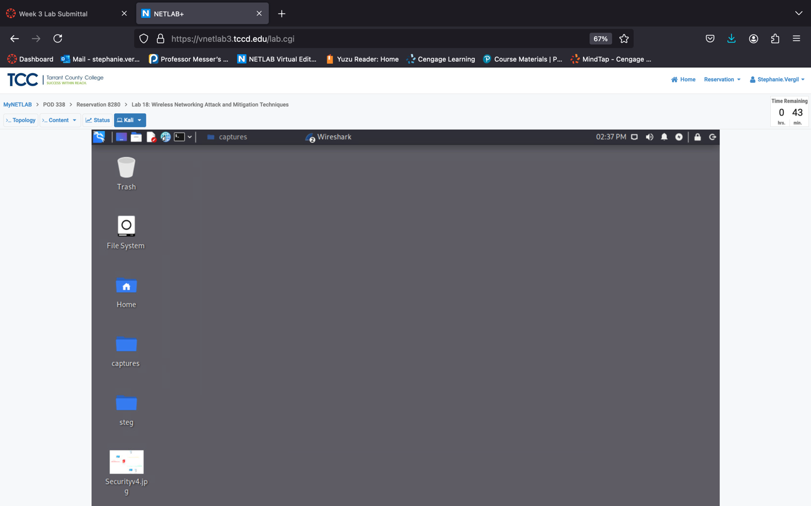

Step 7. Once you view the image once again, close the image viewer.

Step 8. Go back to Wireshark and close the HTTP object list window.

1.1.2 Extract Zip File from FTP Traffic

Step 1. In the Wireshark interface type “FTP” into the filter and press enter. Because FTP is not encrypted, you will be able to see captured FTP traffic as well as clear-text usernames and passwords.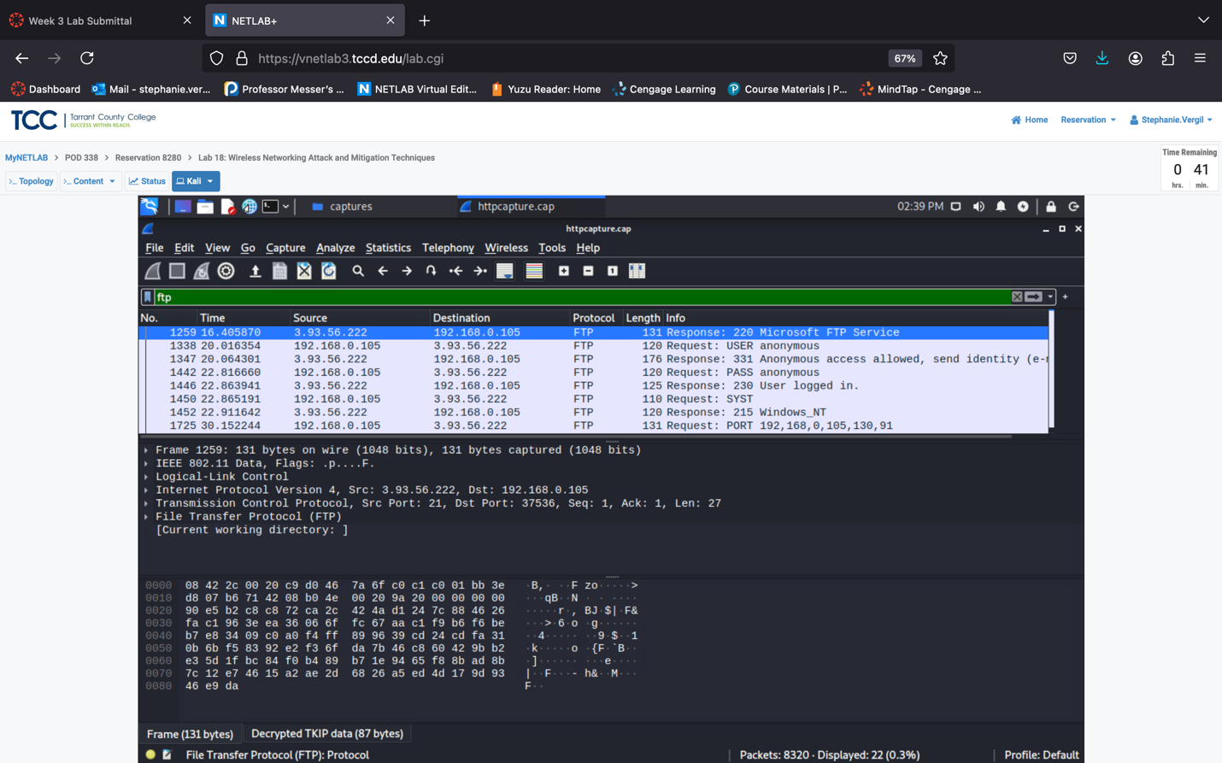



Note: You will want to disable the anonymous user access and use a secured

FTP service for file sharing.

Step 2. To pull a zip file via FTP out of the wireless capture file. Enter “ftp-data and frame contains PK” into the Wireshark filter and press enter.

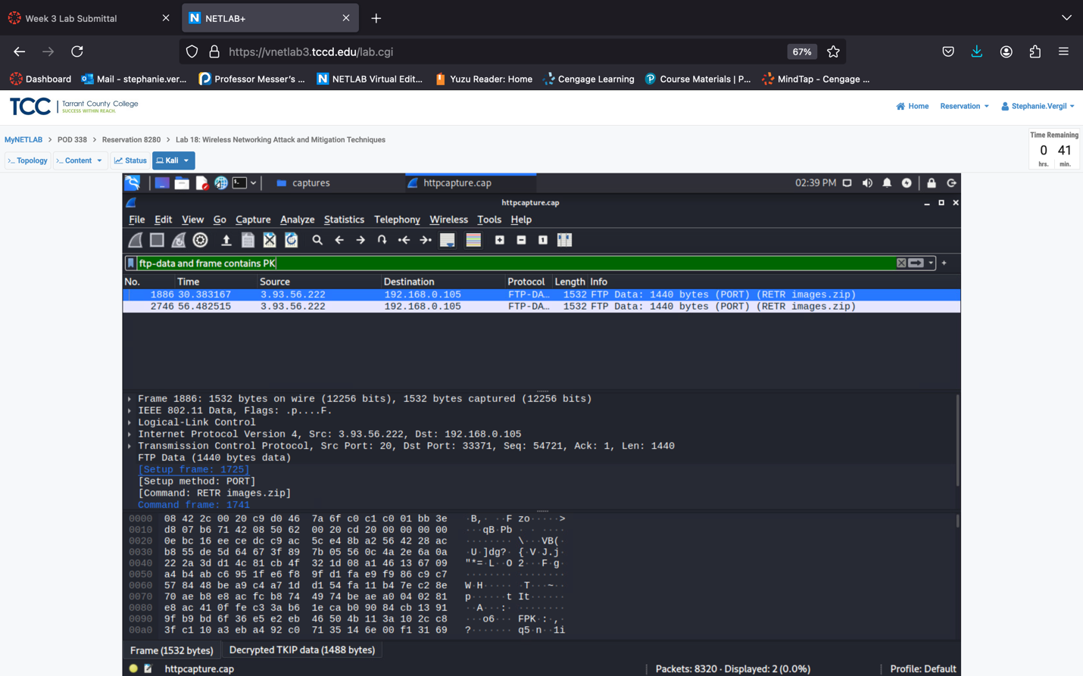



Step 3. Right click on either frame 1886 or 2746 located in the list and select Following, TCP Stream.

Step 4. In the TCP stream examine the data shown. Once you scroll to the bottom of the window and notice the PK attached to the end of filenames.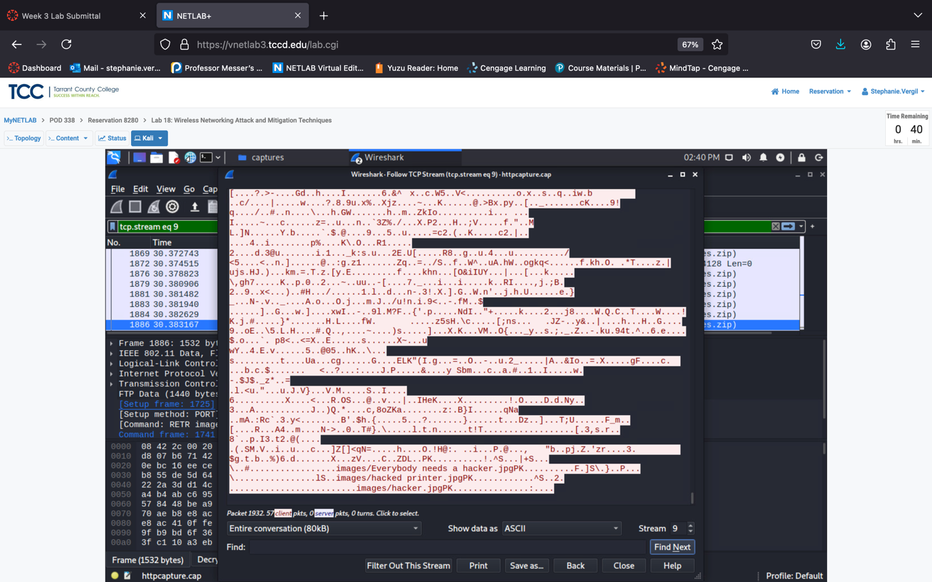



Step 5. Click show data as Raw, and click Save As

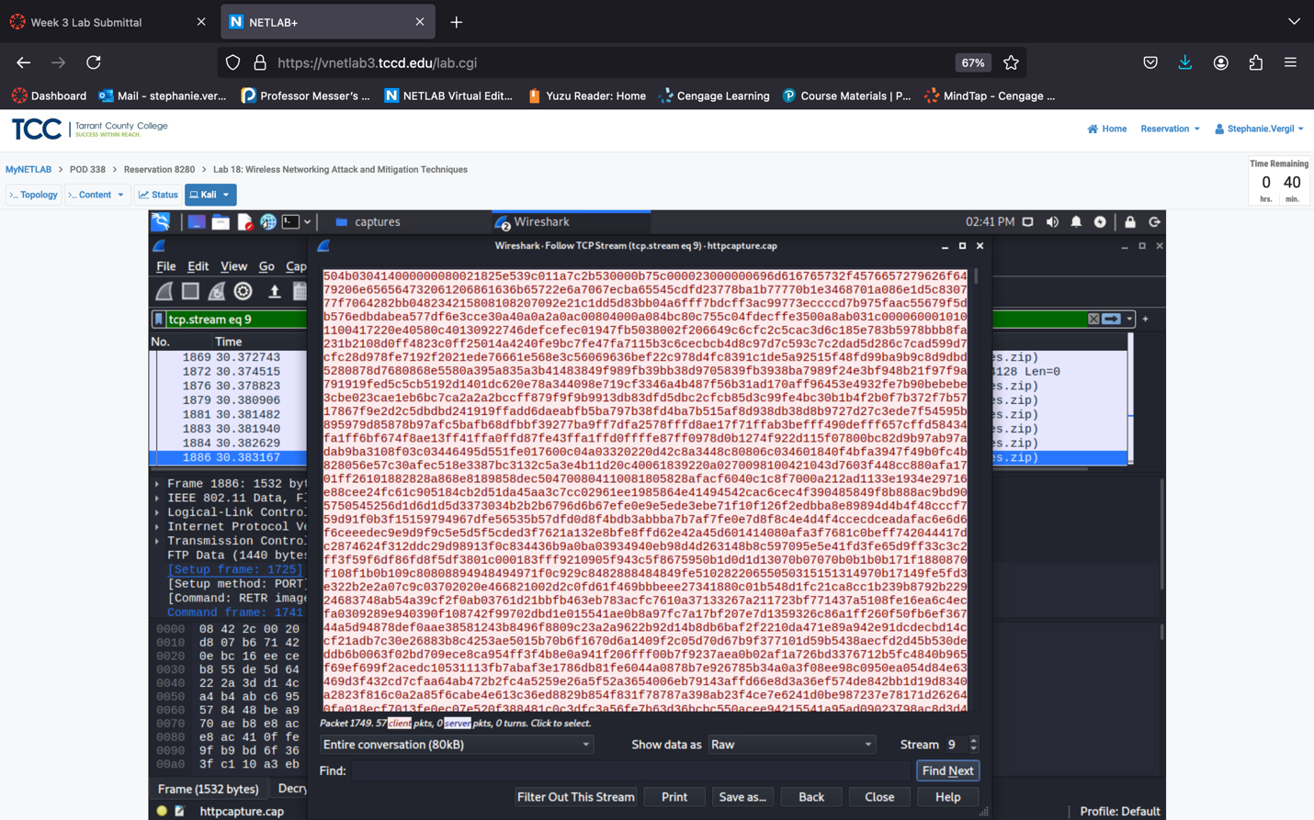

Step 6. Save as “images.zip” saving it at /home/kali/Desktop clicking save.

Step 7. Close the TCP Stream window

Step 8. Launch terminal and type the following command to unzip the file that was extracted from the Wireshark capture file: unzip ~/Desktop/images.zip -d ~/Desktop

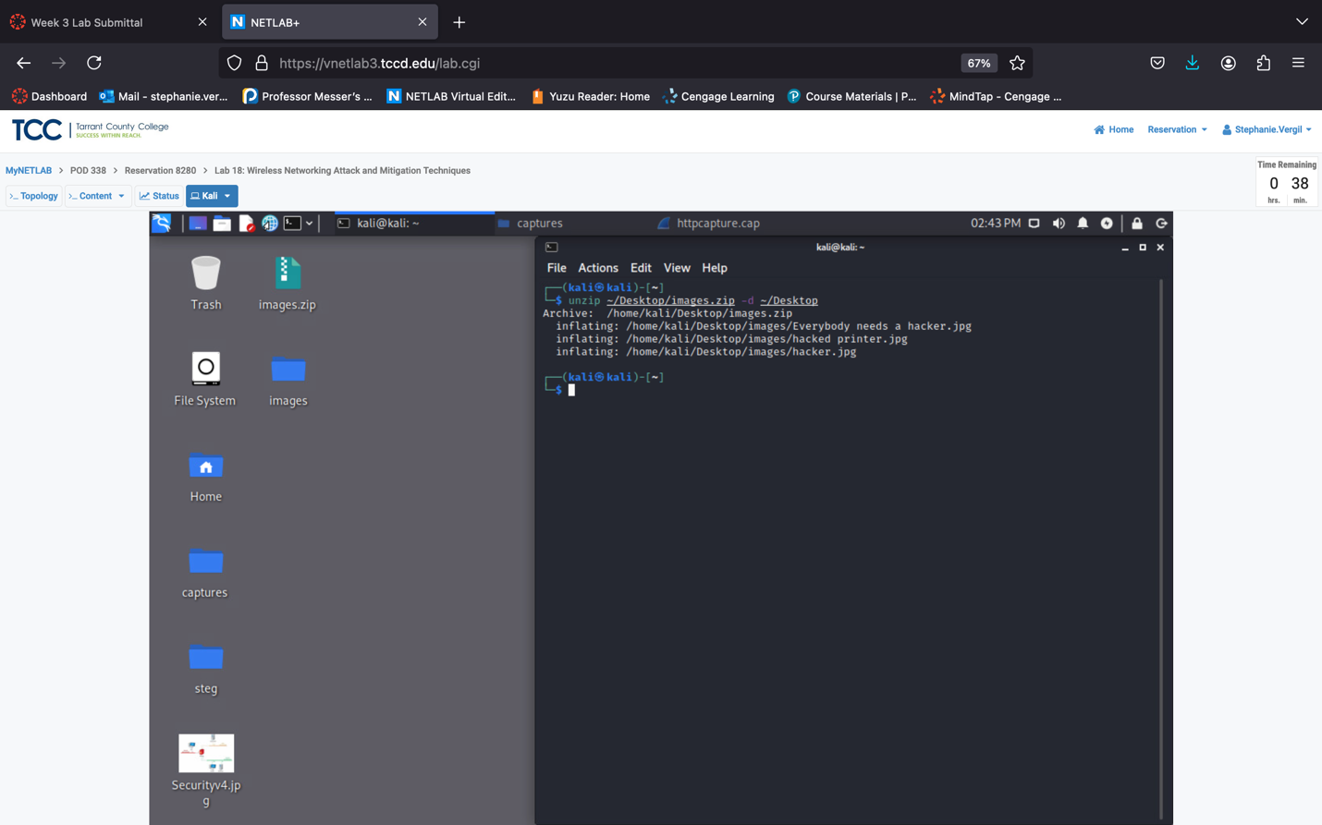



Step 9. Located at the desktop open the images folder.

Step 10. You can view the 3 images that were extracted from the images.zip

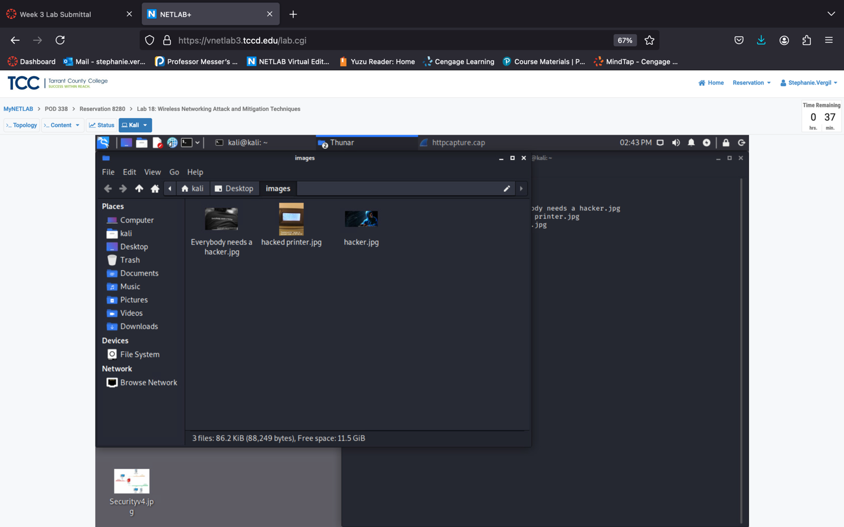

Step 11. Close the images window

Step 12. Leave Kali open for the next steps.

2 Exploiting and Examining WEP Traffic

2.1 Decrypt and Analyze WEP Traffic

Step 1. Restore the httpcapture.cap Wireshark window.

Step 2. Select the file menu option and click open.

Step 3. Make sure you are in the /home/kali/Desktop/captures directory. Open the WEP.cap file and click the Open button.

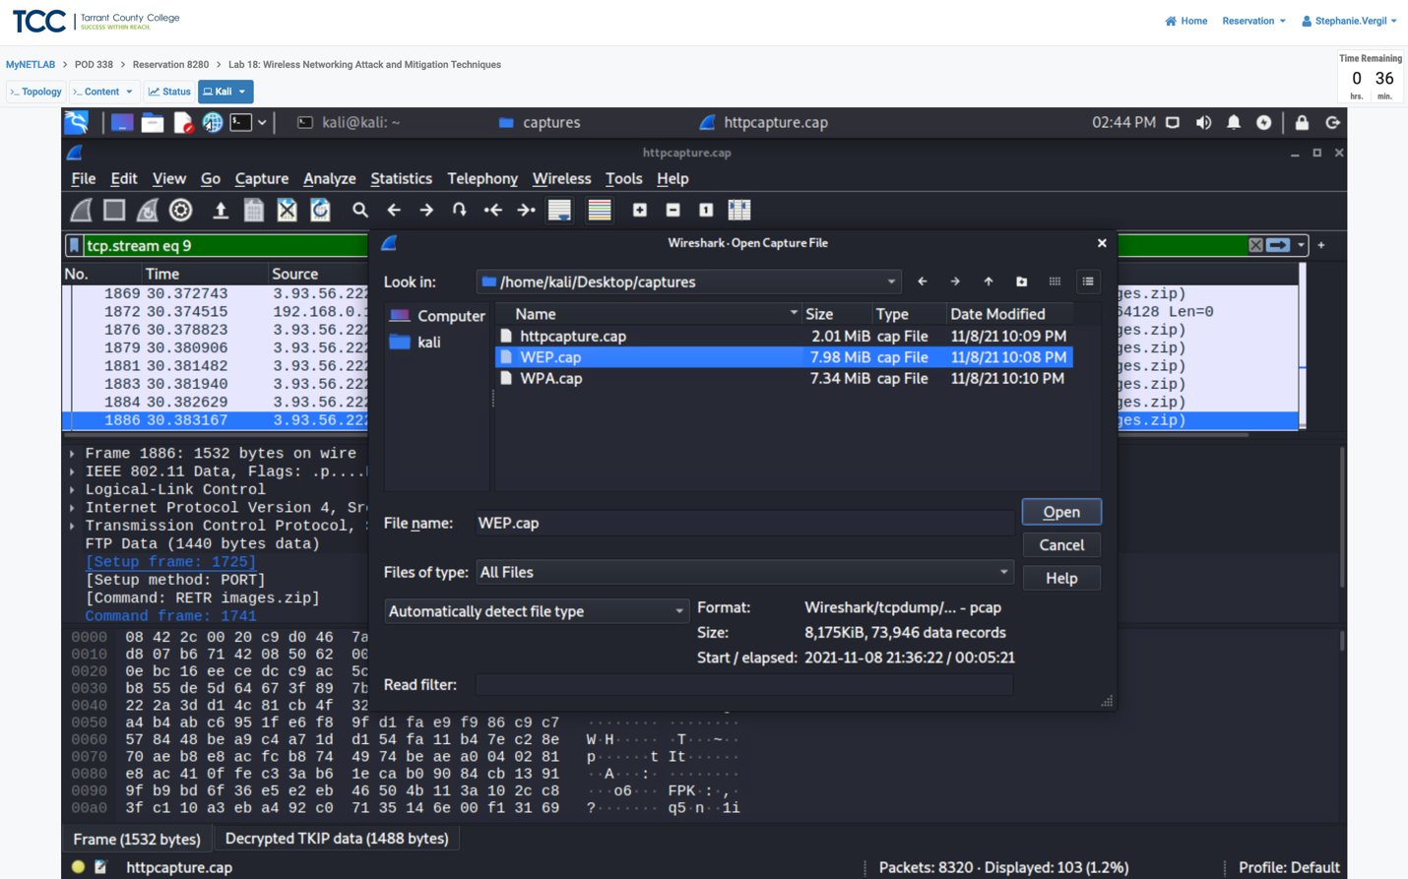



Step 4. In the filter pane enter “dns” and press enter.

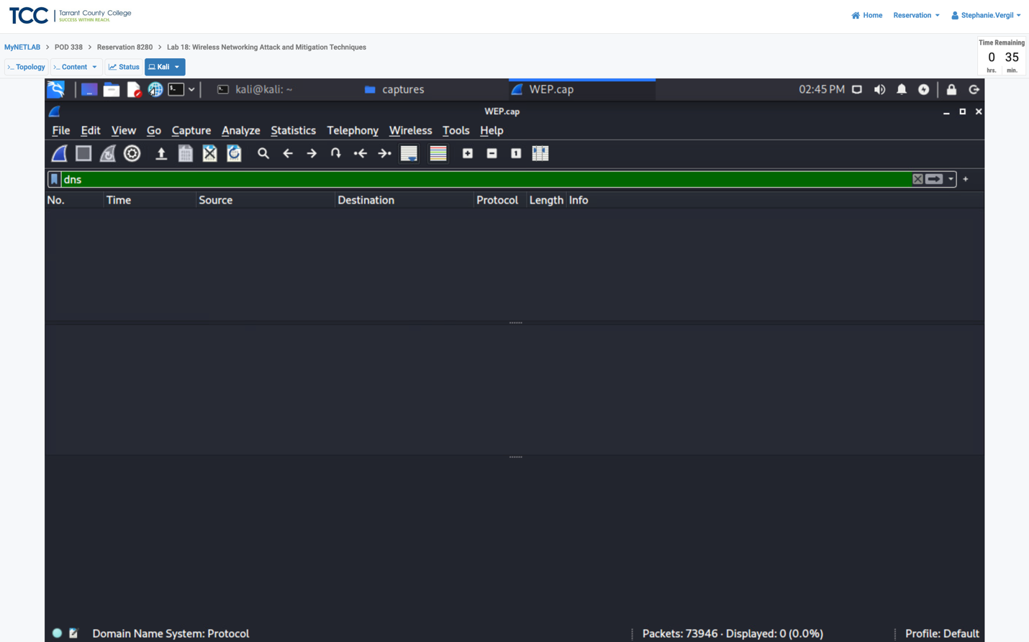



Note: You will not see any traffic displayed because the wireless traffic is

encrypted.

Step 5. Close Wireshark.

Step 6. Go back to the terminal window and enter the following command: aircrack-ng ~/Desktop/captures/WEP.cap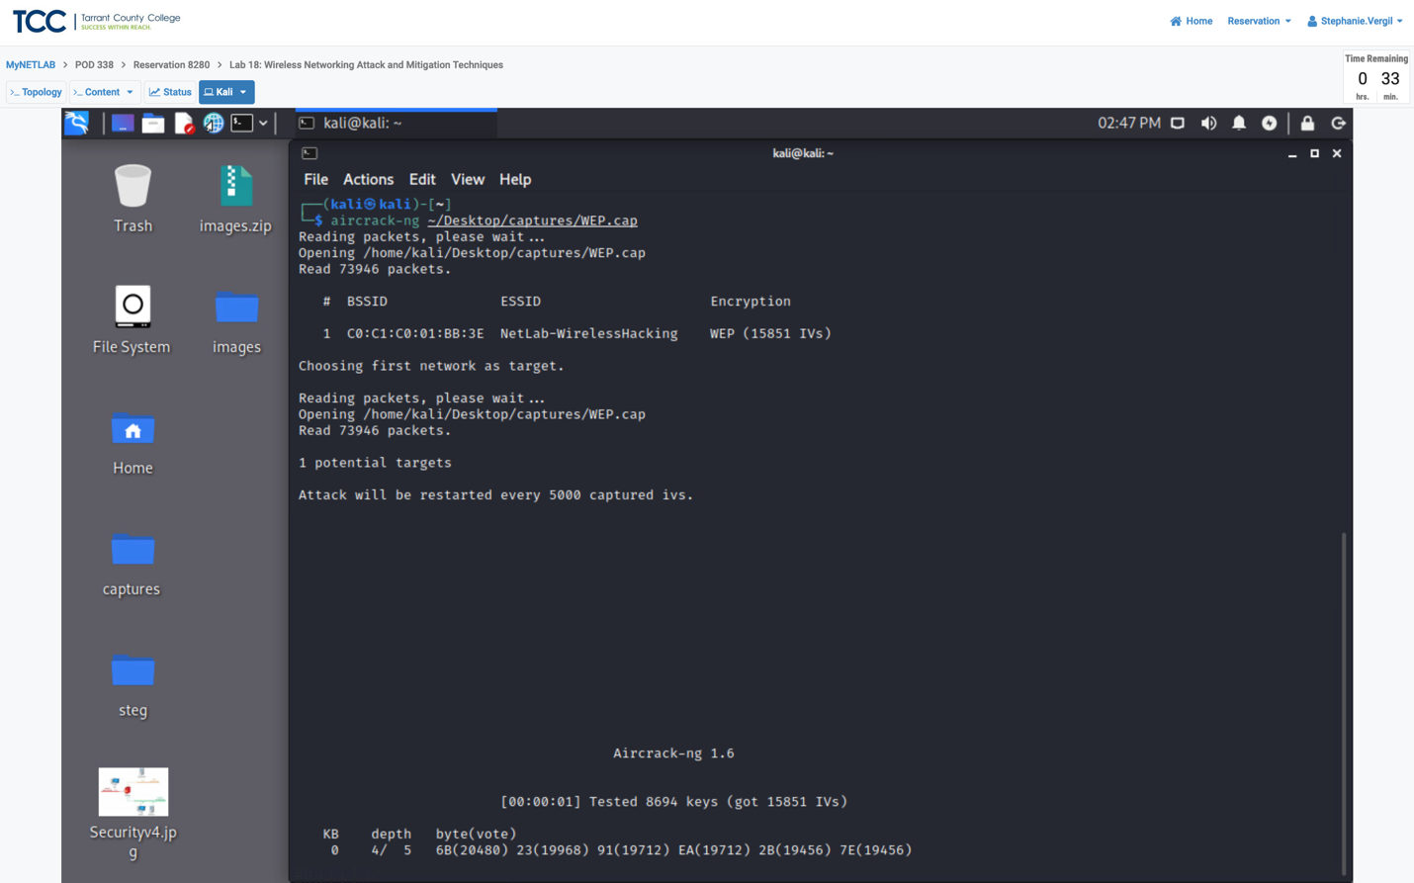



Step 7. After a few seconds, the aircrack-ng program will be able to crack the 64-bit WEP key. Look at the output

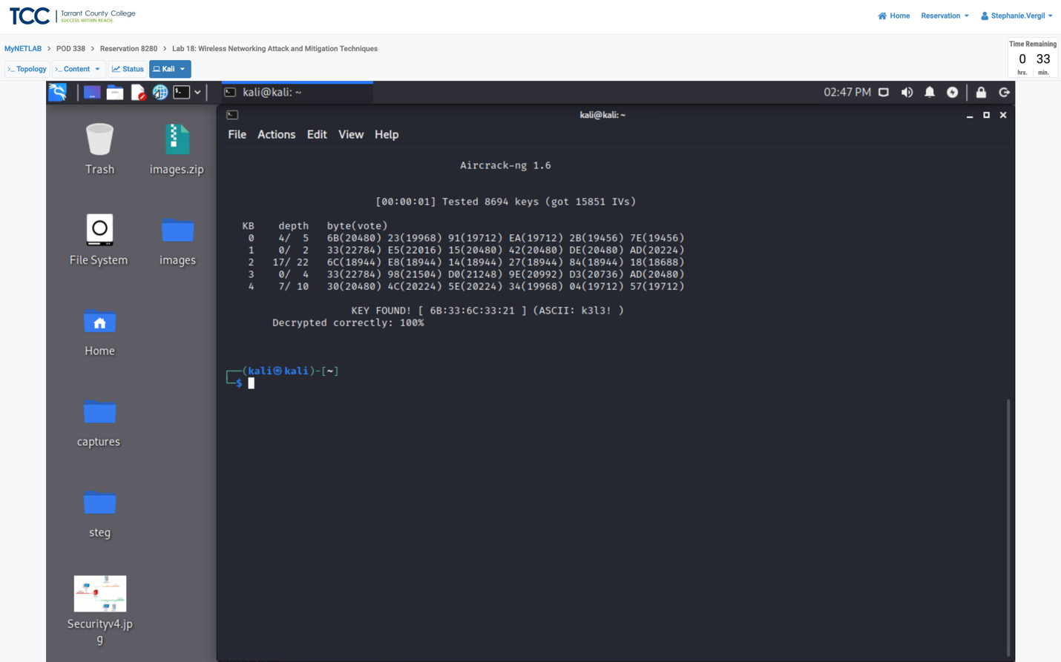



Step 8. Once the WEP key is obtained, decrypt the network traffic with airdecap-ng by entering the following command to decrypt the traffic: airdecap-ng -w 6B:33:6C:33:21 ~/Desktop/captures/WEP.cap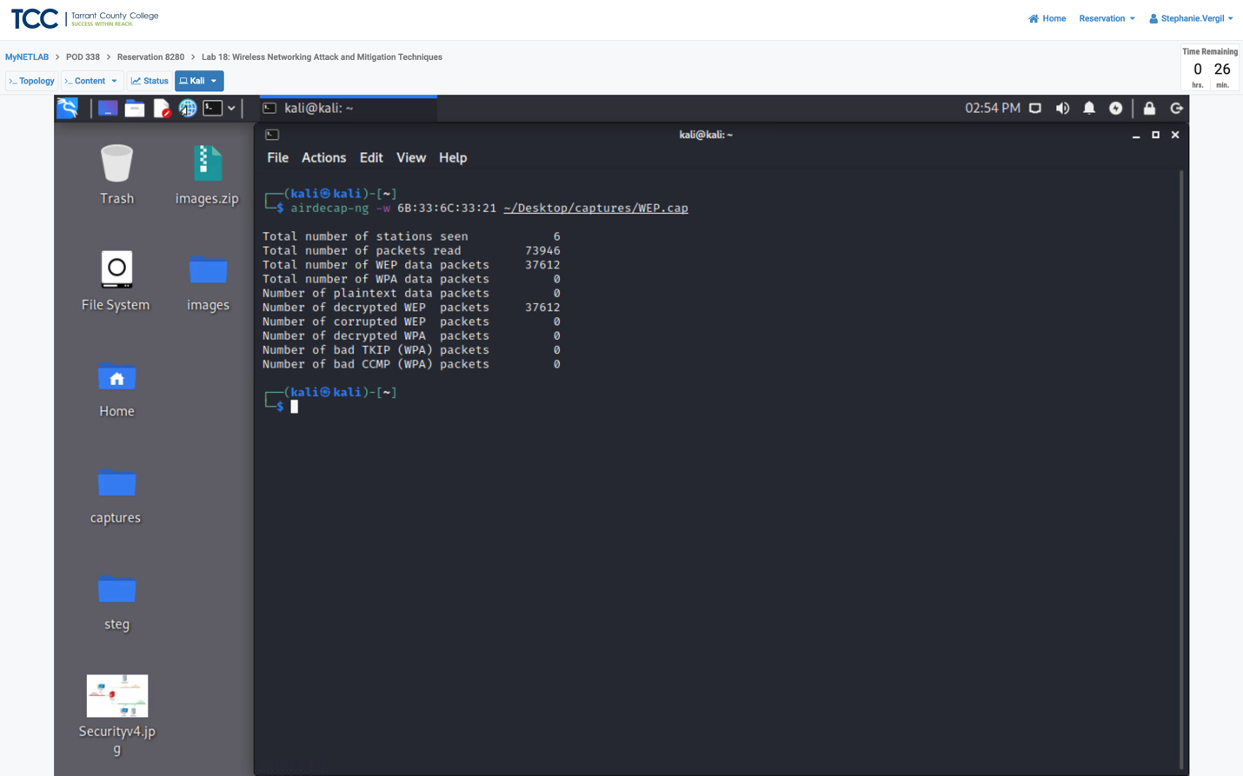



The number of decrypted WEP packets should be 37612.

Step 9. To analyze the decrypted traffic with Wireshark, click on the WEP-dec.cap to open it in Wireshark.

Step 10. In the Filter: pane, type dns and press Enter.

Note: Now you can see the DNS requests within the wireless traffic because the WEP traffic was decrypted with airdecap-ng.

Step 11. Select the File menu option and navigate to Export Objects > HTTP.

Step 12. On the new window, browse through the list and explore what the wireless users were downloading. Under the Packet number column, select item #33076 (pic01.jpg). Once selected, click the Preview button.

Step 13. The image viewer launches showing the image content.

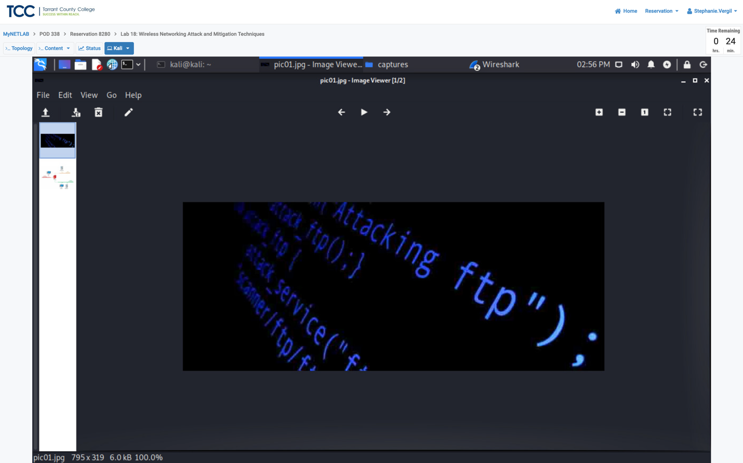

Step 14. Close the Image Viewer window.

Step 15. Close the HTTP object list window.

Step 16. In the Wireshark type ftp into the filter and click enter. Apply. You will

be able to see decrypted FTP traffic as well as clear-text usernames and passwords. Make sure to analyze the FTP traffic.

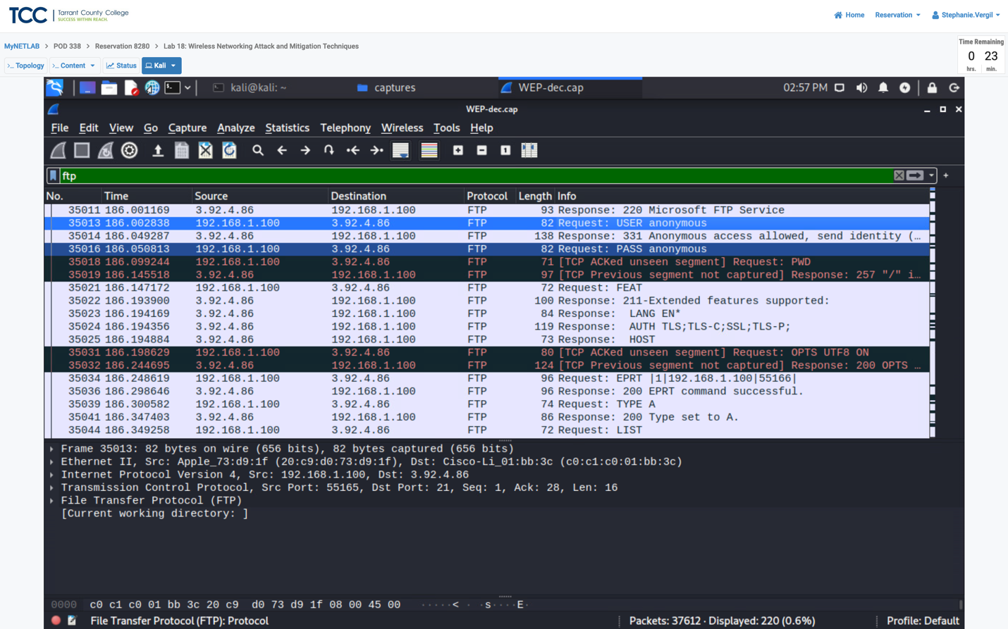



Step 17. To pull a ZIP file transferred via FTP from the wireless capture. Type tcp.stream eq 59 in the Filter pane and press enter.

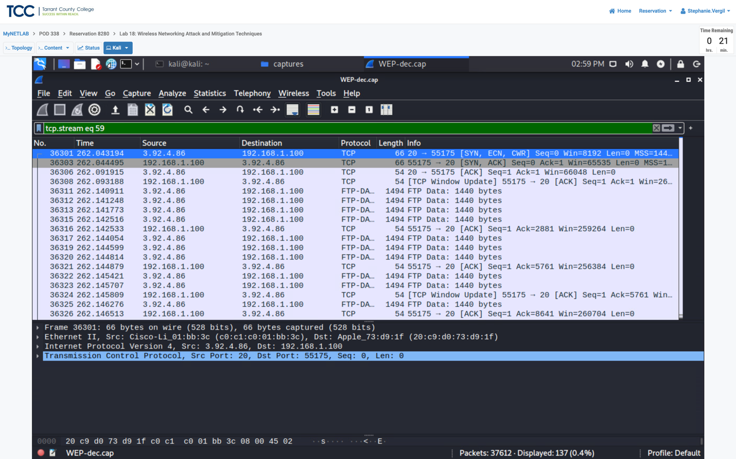



Step 18. Right click on the first frame in the list and select follow, TCP Stream.

Step 19. A new window pops up, change the show data as to Raw and click the Save as button.

Step 20. Save as netlab.zip. Make sure the directory is set to /home/kali/Desktop/captures and click the Save button.

Step 21. Close the Follow TCP Stream window.

Step 22. Double-click on the netlab.zip file to open it.

Step 23. A new window opens, showing the content of the zip file. Feel free to check the content in the netlab folder.

Step 24. Once done exploring the files, close the netlab.zip window.

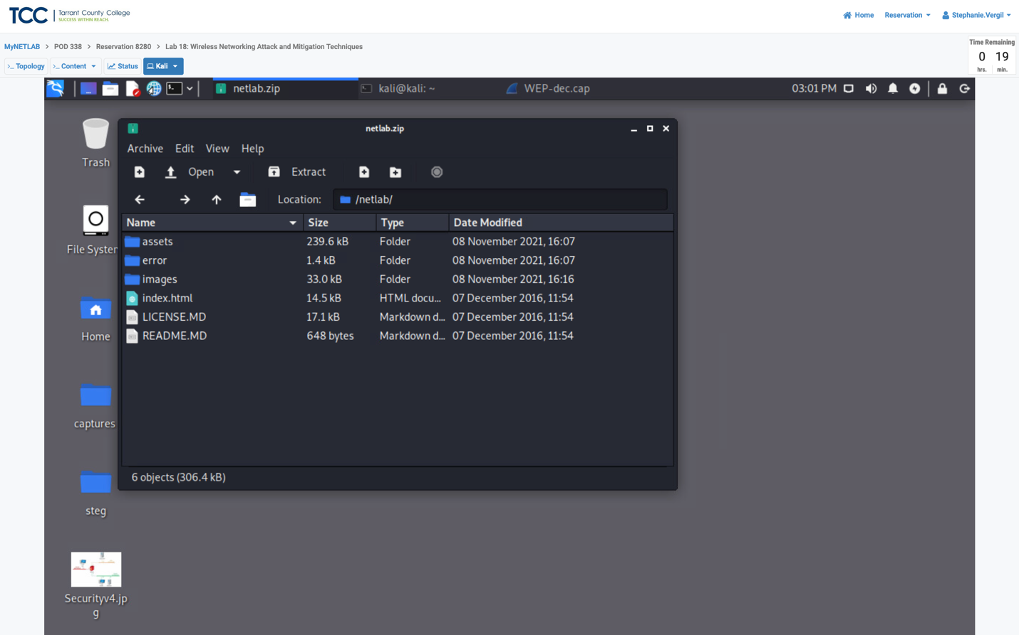

3 Exploiting and Examining WPA Traffic

3.1 Exploiting and Examining WPA Traffic

Step 1. Open a WPA capture file by selecting file option and clicking open.

Step 2. Navigate to the /home/kali/Desktop/captures directory and open the WPA.cap file.

Step 3. In the Filter pane, type ftp and press Enter.

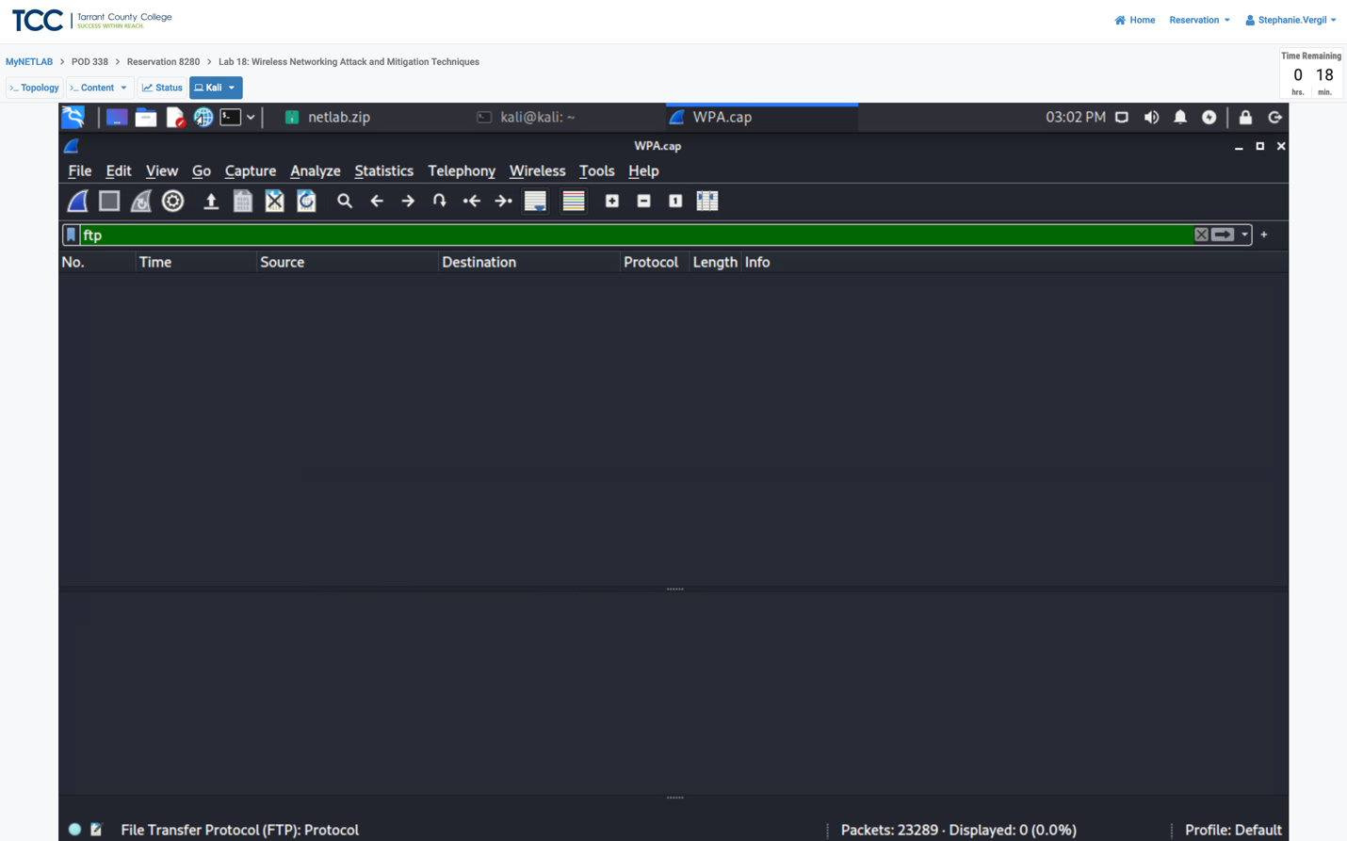



Note: You will not see any traffic because the wireless network traffic is

encrypted.

Step 4. Open the terminal window and type the following command: aircrack-ng ~/Desktop/captures/WPA.cap -w /usr/share/john/password.lst

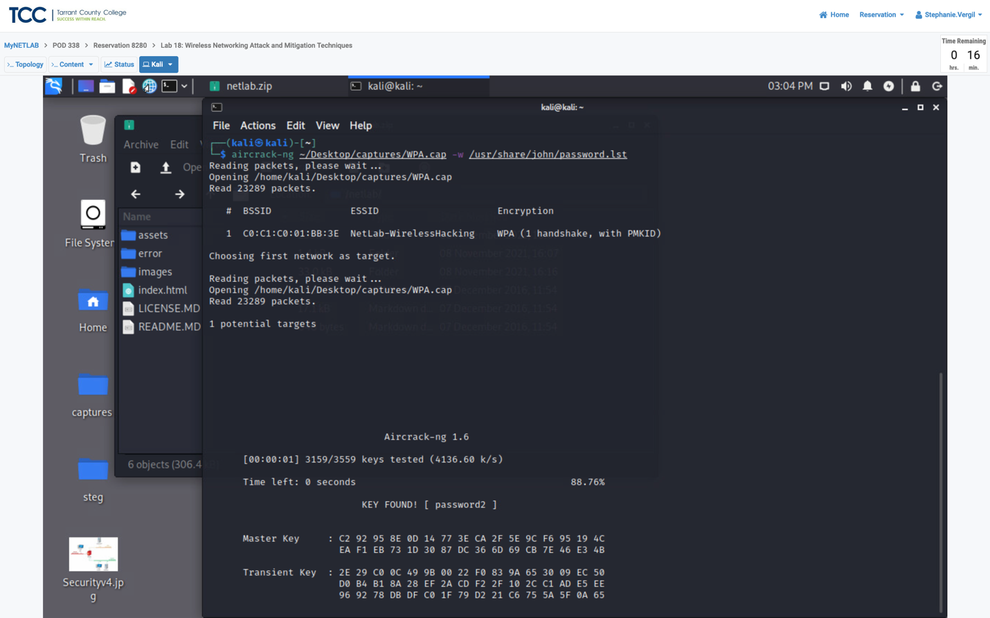



Step 5. After a couple of seconds, the WPA passphrase is obtained.

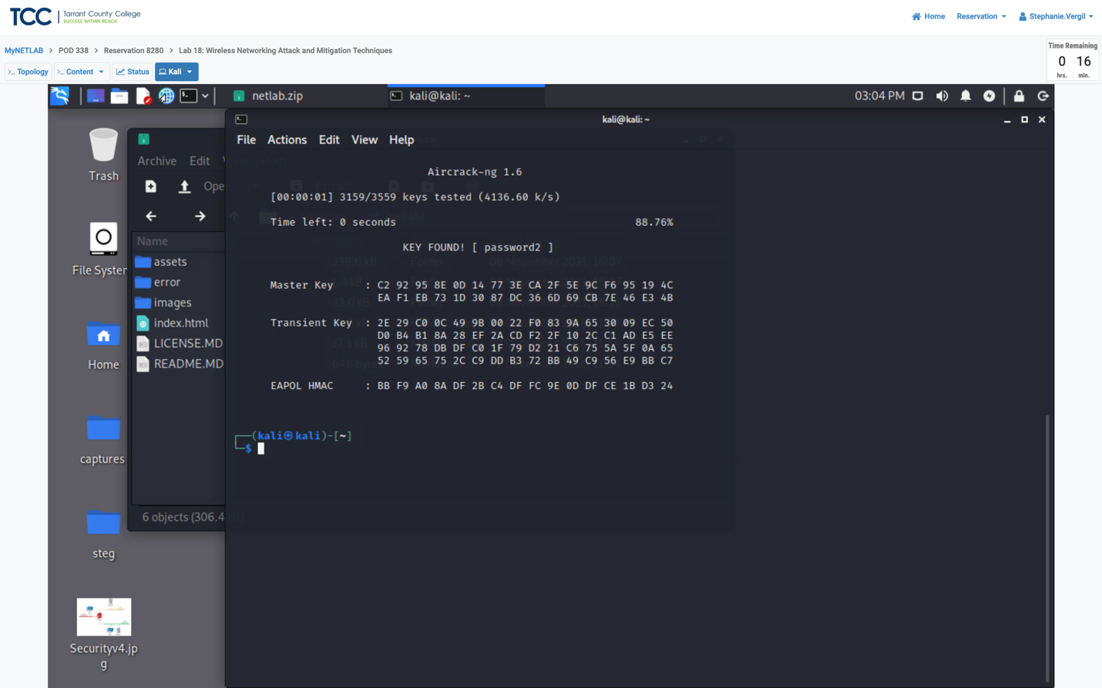



Step 6. To Decrypt the traffic for the wireless network NetLab-WirelessHacking. Type the command to decrypt the traffic: airdecap-ng ~/Desktop/captures/WPA.cap -e NetLab-WirelessHacking -p password2

Note: The number of decrypted of WPA packets should be 9855.

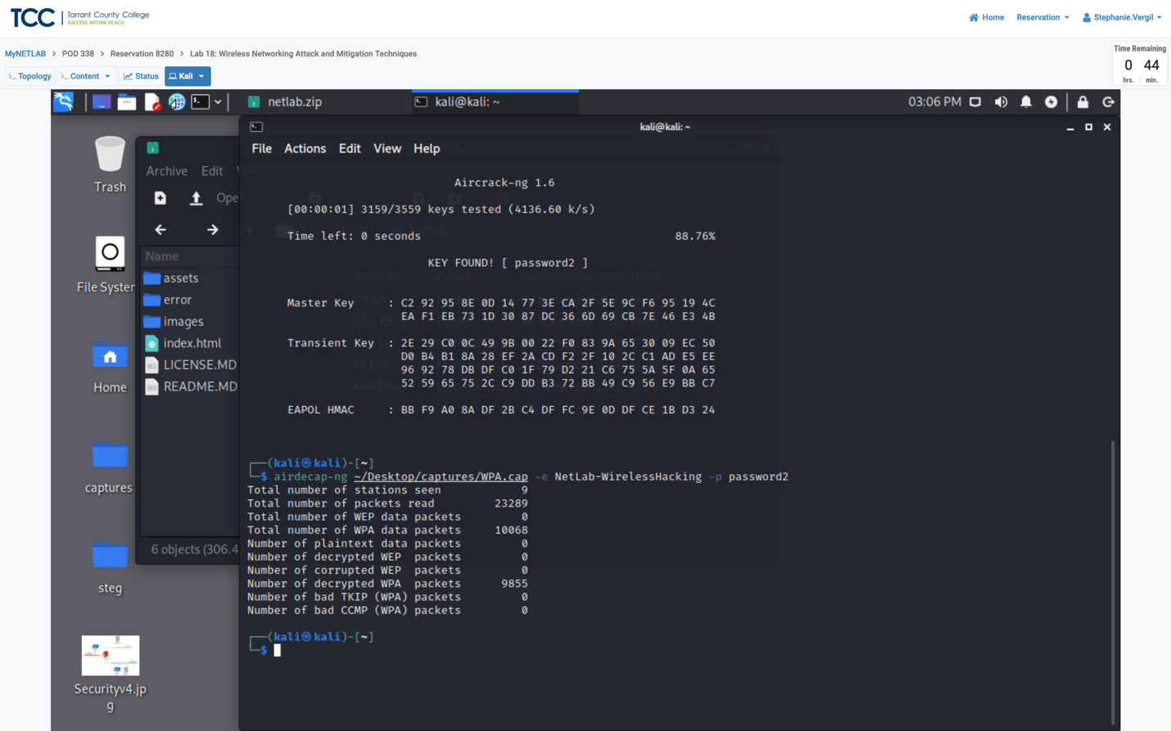



Step 7. Change focus to the Captures window.

Step 8. launch the WPA-dec.cap file to open it in Wireshark.

Step 9. In the Filter pane, type dns and press Enter.

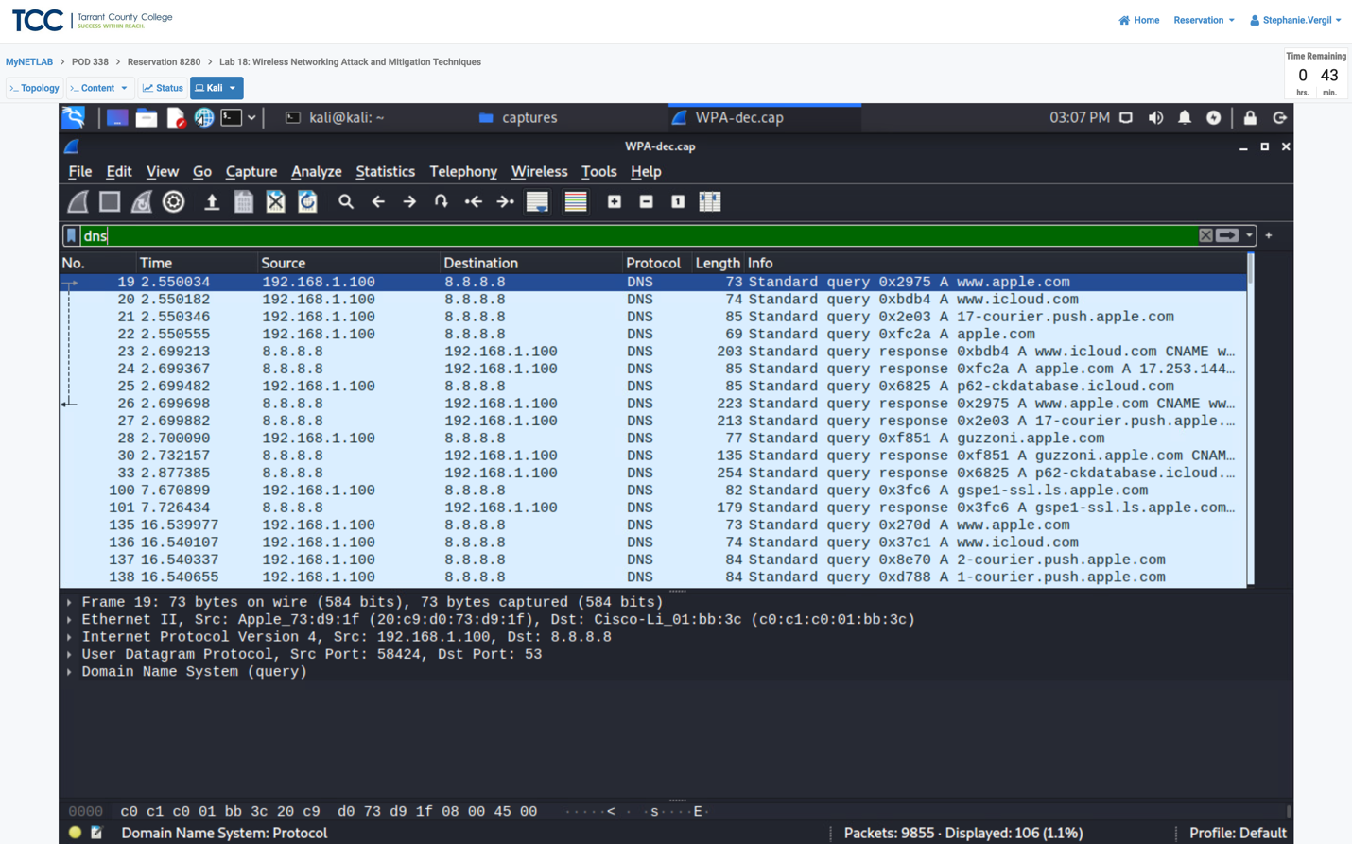



Note: You will now be able to see DNS requests with the decrypted wireless traffic.

Step 10. Select the File menu option and navigate to Export Objects > HTTP.

Step 11. When the window appears. View the list and examine what the wireless users were downloading. Under the Packet number column, find item #676 (pic01.jpg) and select it. Click the Preview button.

Step 12. The Image Viewer window opens, showing the content of the image.

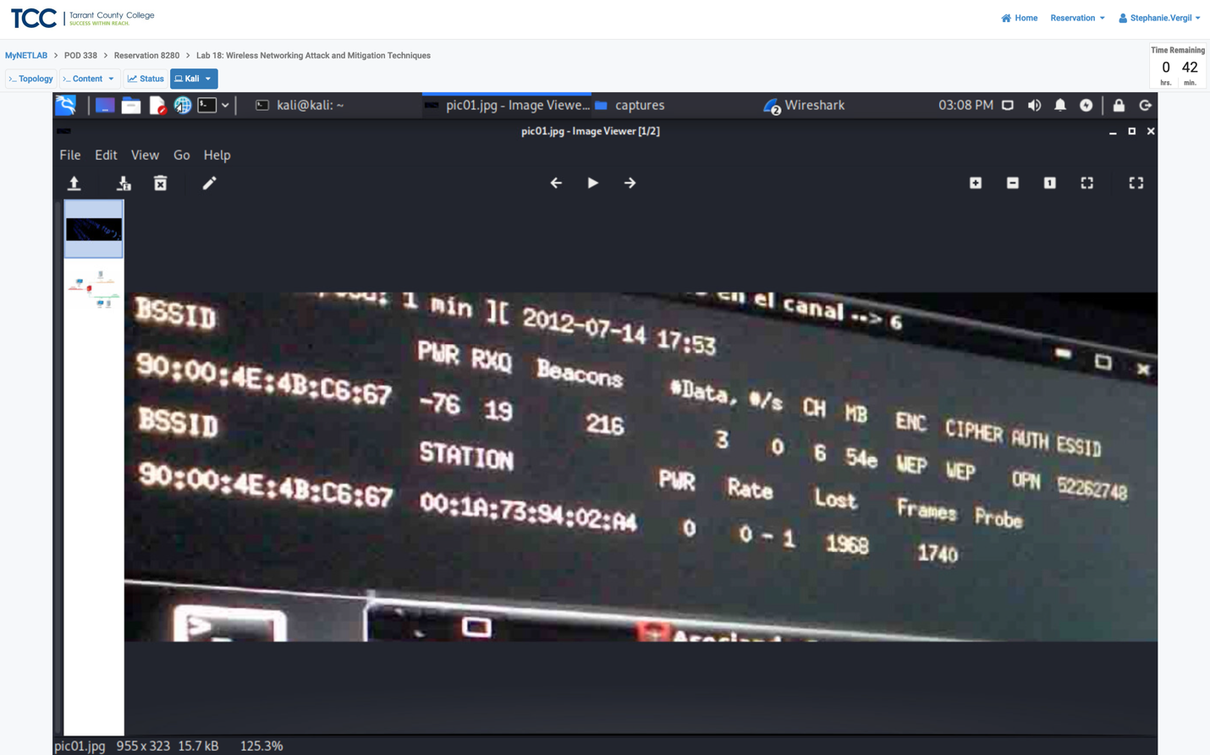

Step 13. Close the Image Viewer window and the HTTP object list window.

Step 14. Type ftp in the filter pane and press enter in the Wireshark application.

Note: You will now be able to see the decrypted FTP traffic along with clear

text usernames and passwords.

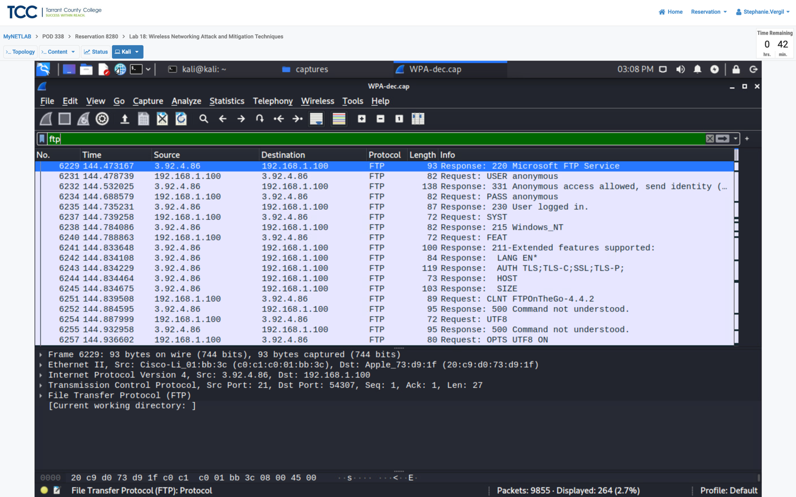



Step 15. Scroll down through the ftp frames and examine the file names that were transferred.

Step 16. To pull one of the zip files transferred via FTP. Type tcp.stream eq 75 into the Filter: pane. Press Enter.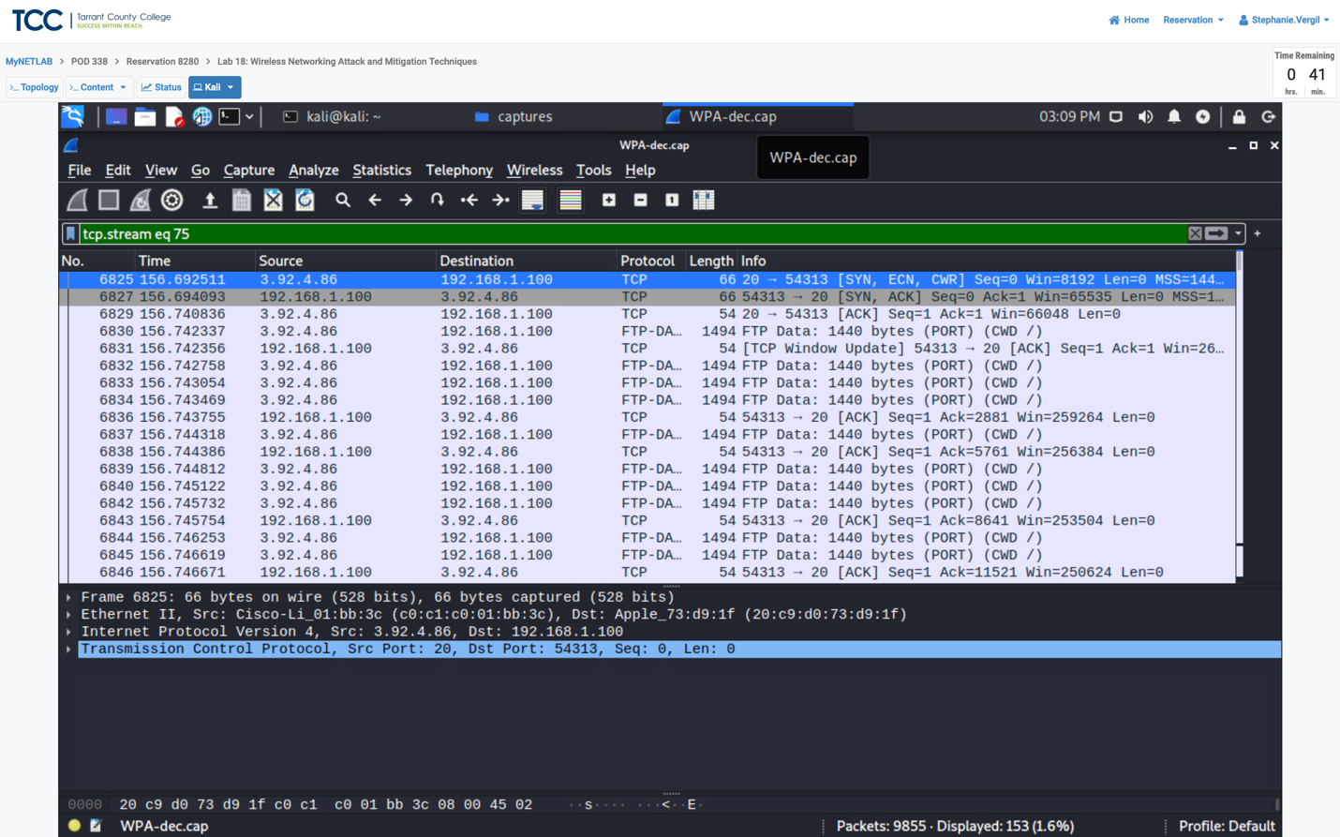



Step 17. Right-click on the first frame in the list (#6825) and select Follow > TCP Stream.

Step 18. When the new window opens. Change the Show data as to Raw, then click the Save as button.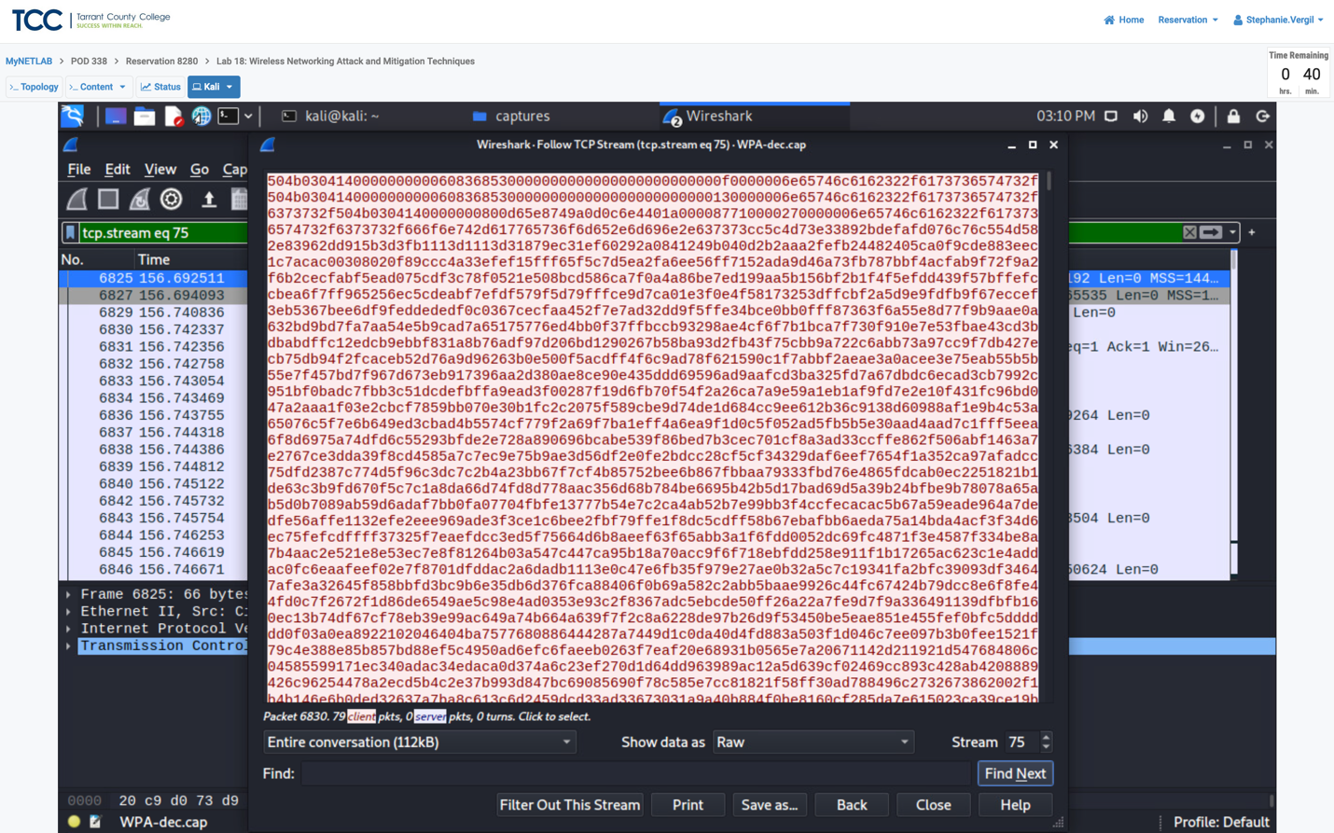

Step 19. Save as netlab2.zip. Verify the directory you are saving the file to is

/home/kali/Desktop/captures. Click Save.

Step 20. Close the Follow TCP Stream window.

Step 21. Double-click the netlab2.zip file to open it.

Step 22. Explore the content in the netlab2 folder.